Biology, Castle View High School
Dr. Jason R Mayberry
Study Guide: Solutions
Vocabulary Summary:
- Solution
- Solvent
- Solute
- Hydrophilicp
- Hydrophobic
- Universal Solvent
- Acid
- Base
- pH
- Electrical Current
Conceptual Questions:

- What is the relationship between a Solute, a Solvent, and a Solution.
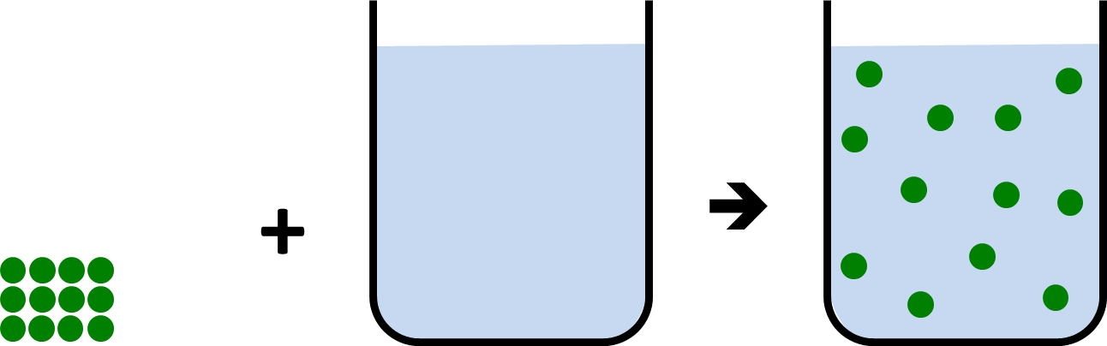

- What properties of a substance make it Hydrophilic?

- How can you predict from the chemical formula whether or not a substance will be hydrophilic?

- Compare and contrast what happens when ionic substances dissolve in water and molecules with polar-covalent bonds dissolve in water – give an example of each.
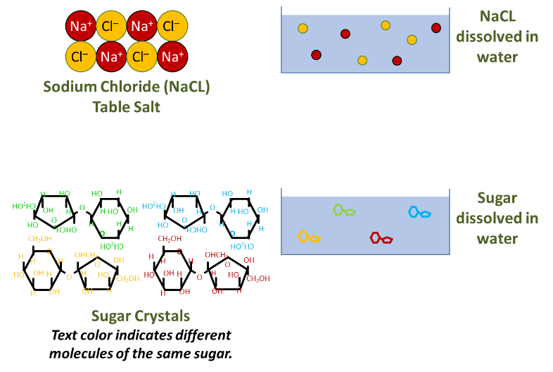
- What properties of a substance make it Hydrophobic?

- How can you predict from the chemical formula whether or not a substance will be Hydrophobic?

- What does it mean for something to be acidic?

- What does it mean for something to be basic?

- Explain what pH is, and how it relates to acidity, and H+ ion concentration?

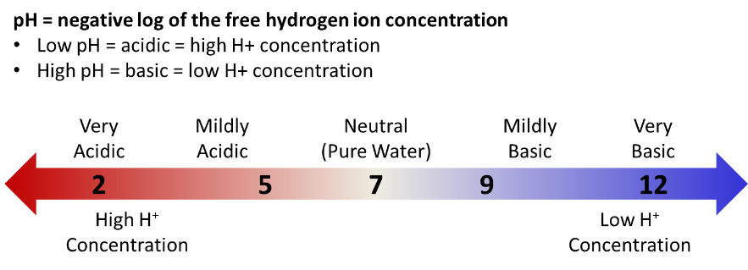
- Why is water essential for life?

- What is electricity?

- How can water promote generation of an electrical current?
